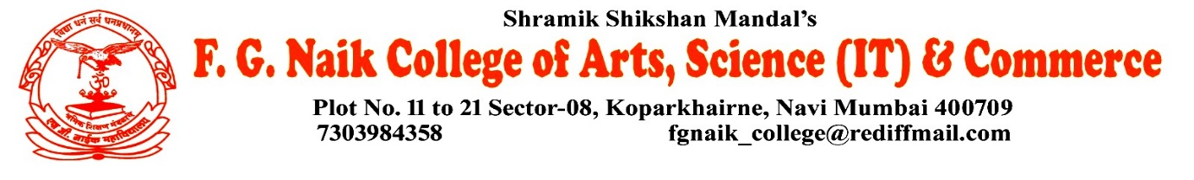

NSS UNIT
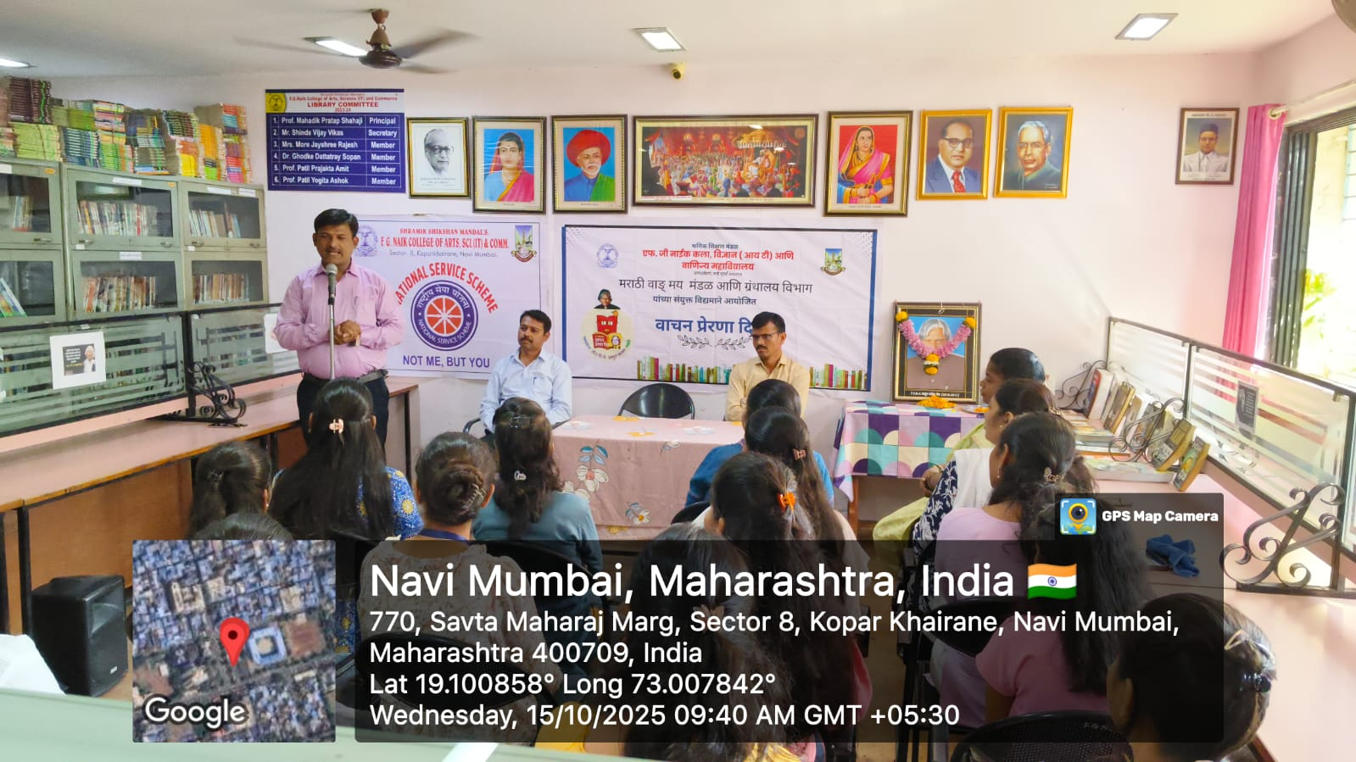
VACHAN PRERNA DIWAS

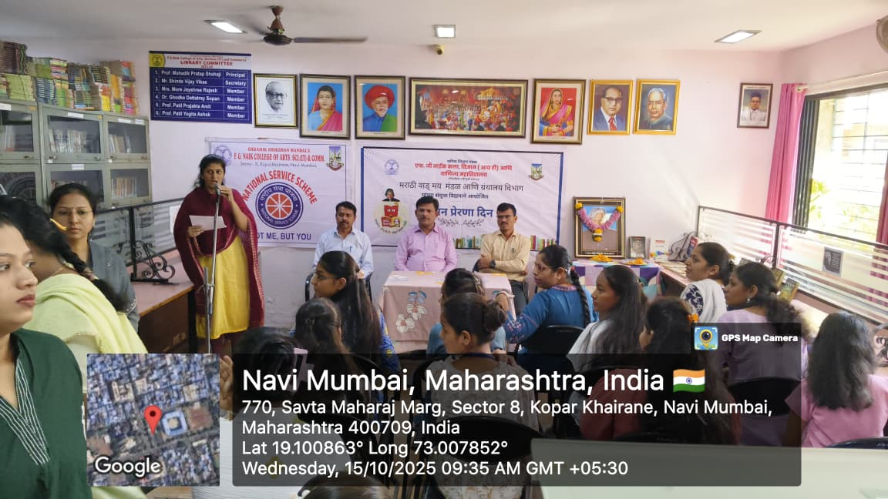

OBJECTIVE OF PROGRAM: To promote the habit of reading among students and inspire them to develop knowledge, values, and critical thinking through books and reading activities.
DATE: 15/10/2025
LOCATION: F.G Naik College Library
PARTICIPATING STAFF: All the NSS volunteers, teaching and the non-teaching staff of the college.
NUMBER OF VOLUNTEERS PARTICIPATING: 24
The NSS Unit organized Vachan Prerna Diwas in the college library to encourage students to cultivate a regular reading habit. The program emphasized the importance of books in personal growth, education, and character building. Students were motivated to read inspirational literature and understand the value of lifelong learning.
The program helped in creating a calm and thoughtful environment in the library, inspiring students to explore books beyond their academic curriculum. It also highlighted the role of reading in shaping responsible and informed citizens.
PROGRAM DETAILS: The program commenced with a formal welcome, creating a peaceful and encouraging atmosphere for the event.
The NSS Unit successfully conducted Vachan Prerna Diwas at the library, reinforcing the importance of reading as a powerful tool for self-development and intellectual growth.

NSS IQAC
PROGRAM OFFICER CO-ORRDINATOR I/C PRINCIPAL

